**Project Development –Delivery plan sprint-1**

IoT Based Safety Gadget for Child Safety Monitoring & Notification

**TEAM ID:** **PNT2022TMID02457**

# Creating and Connecting IBM cloud for Project and Python Code

**Creating IBM Cloud Service and creating the device:**

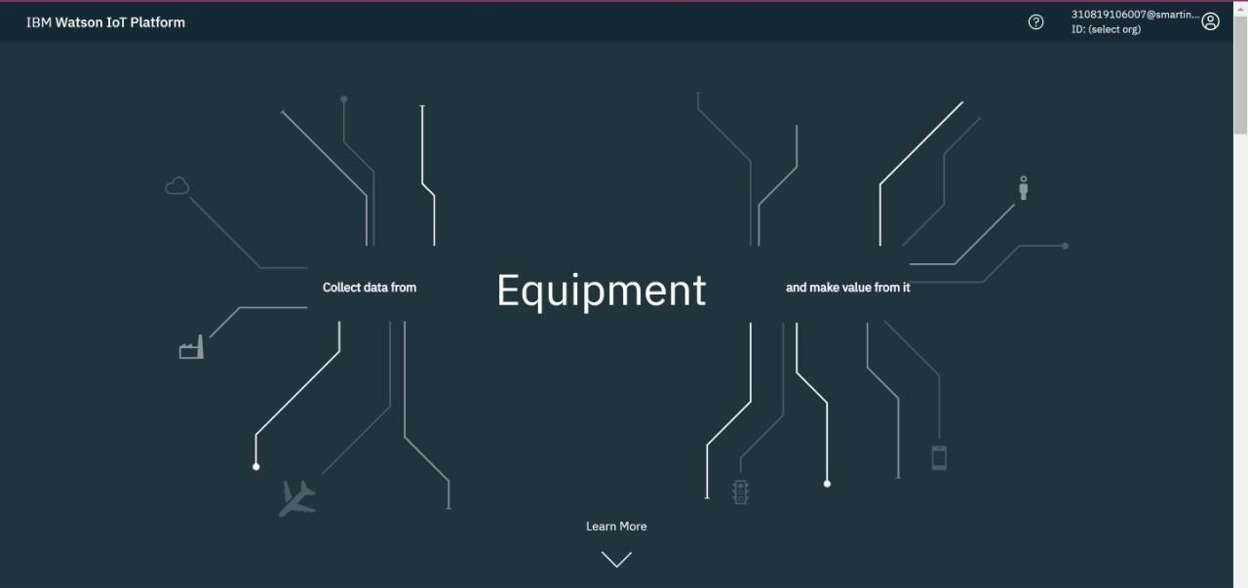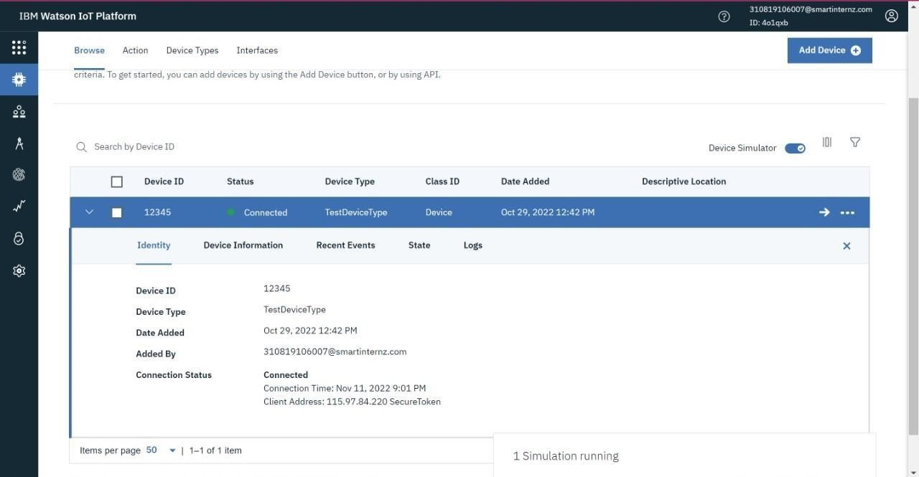

**Creating Python Code:**

import json import wiotp.sdk.device import time import random myConfig = {

"identity":{

"orgId": "4o1qxb",

"typeId": "TestDeviceType",

"deviceId": "12345"

},

"auth": {

"token":"pnhXvzN-sWMKv&hxyi"

}

}

client = wiotp.sdk.device.DeviceClient(config=myConfig, logHandlers=None) client.connect()

while True:

name= "Smartbridge"

#in area location

latitude= 17.4225176 longitude= 78.5458842 #out area location

#latitude= 17.4219272 #longitude= 78.5488783

myData={'name': name,'lat':latitude, 'lon' :longitude}

client.publishEvent(eventId="status", msgFormat="json", data=myData,

qos=0, onPublish=None) print("Data Published to IBM IoT platfrom: ", myData) time.sleep(5)

client.disconnect()

**Connecting IBM Watson and python Code:**

**In-Area Location:**

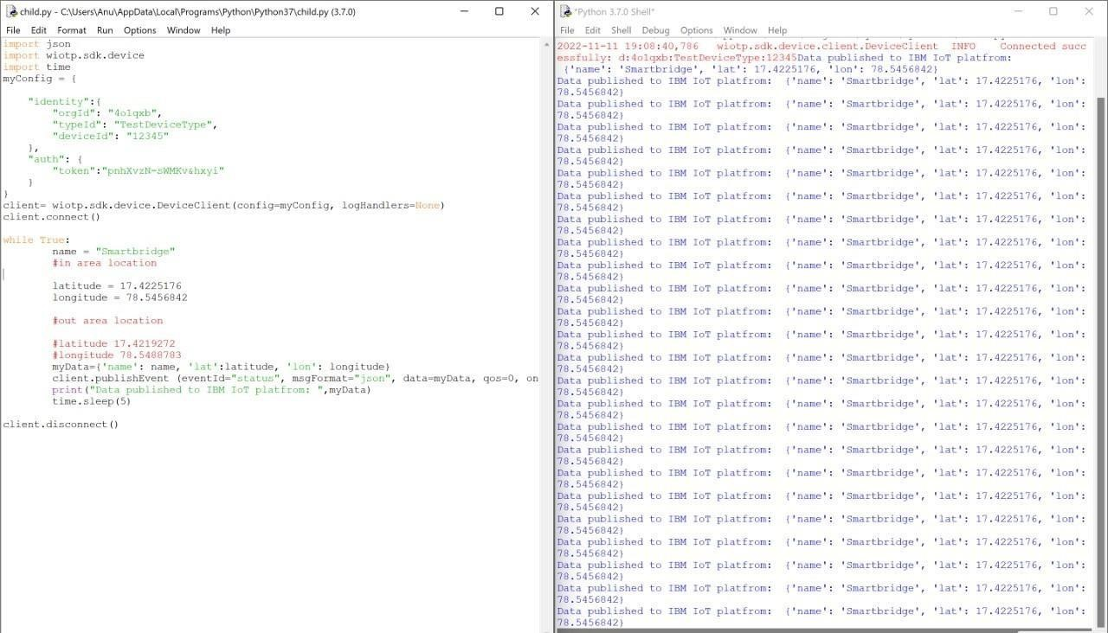

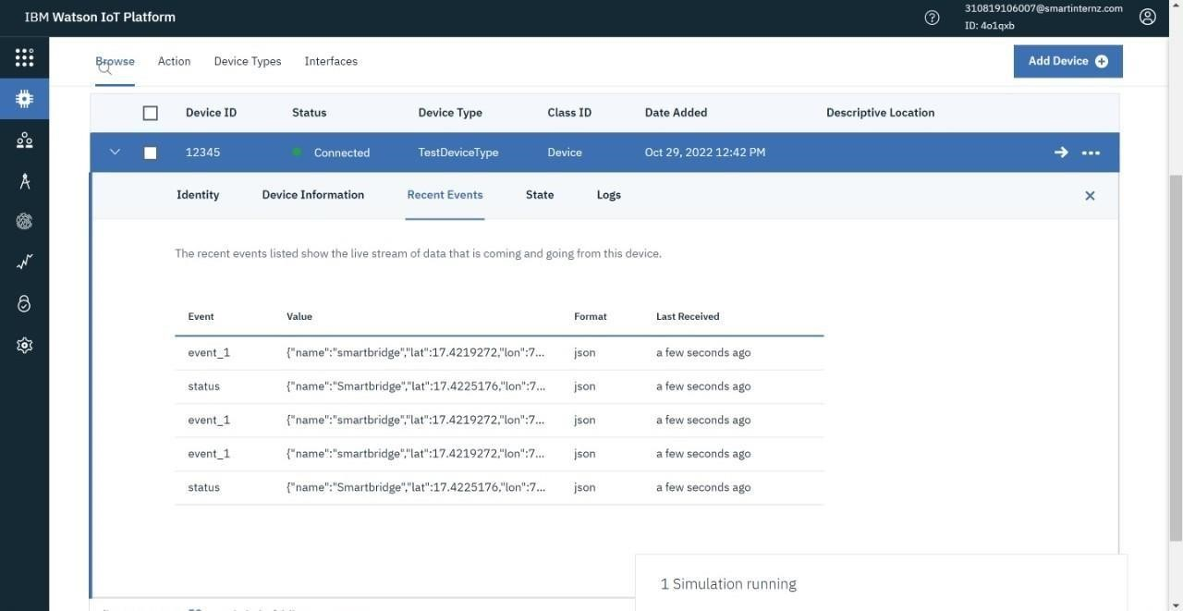

**Out-Area Location:**

